Credit Card validation Project

1. Launch eclipse
2. Download the zip file
3. Unzip it using winzip or any other utility
4. In Eclipse , click on file on menu bar .
5. Select import option from dropdown menu
6. Pop up window will appear
7. Expand the general tab
8. Select projects from folder and archive option and click next
9. Using Directory button , locate the folder and click ok
10. Then click on finish
11. Click on Windows in menu bar
12. show view -> Project explorer (You’ll see the project into the project explorer )
13. Right click the project and select preferences .
14. Setup Apache tomcat server 8.0
15. Setup wampserver with CreditCard database (“Refer screenshot below”)
16. 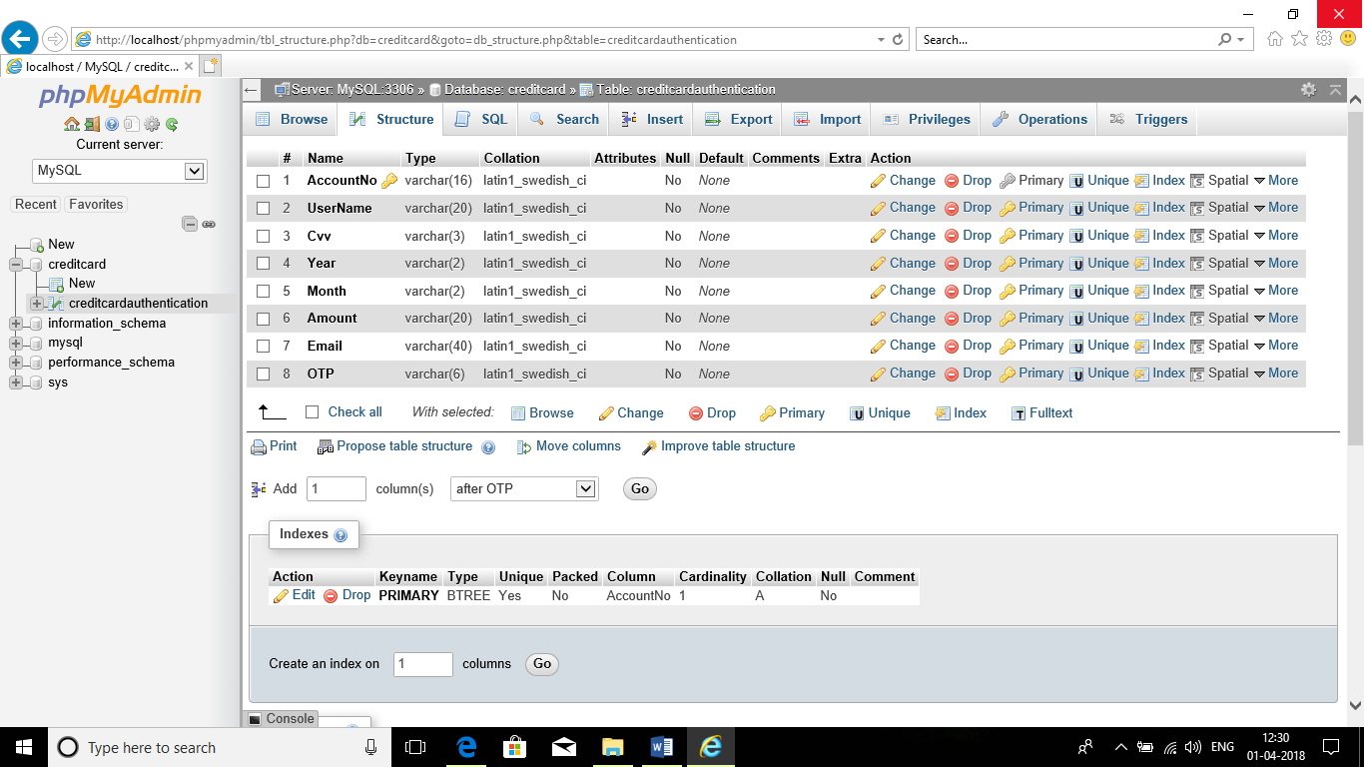
17. Apply and close .
18. In java build path locate all four jar files in “jar files” folder and add them to project .
19. Add library , Jre system library
20. Right click on first.jsp
21. In drop down menu , select run as -> run on server
22. Select localhost server 8.0



